Mode of Exam
OFFLINE
FAI QUESTION BANK
(Note: similar type of questions will come, problems will differ, given here are sample examples)
Question paper pattern:5 questions*20M=100M

(unit 1 and II)

- Is String a mutable data type? Also explain the various string operations, indexing and slicing in detail with an appropriate example.
ii) Create a NumPy array of the following product prices: [100, 250, 300, 450, 150]. Perform the following operations.
a. Find the mean price of the products.
b. Filter and display the rows where the Category is "Electronics" and the Total_Sales is greater than 10,000.
c. Create a bar plot using Matplotlib that shows the Product_Name on the x-axis and the Total_Sales on the y-axis for the top 5 products with the highest total sales.
d. Add appropriate labels for the x-axis, y-axis, and the title for the plot.
e. Identify and explain which columns in the "sales_data.csv" dataset are examples of categorical data and which ones are numerical data.
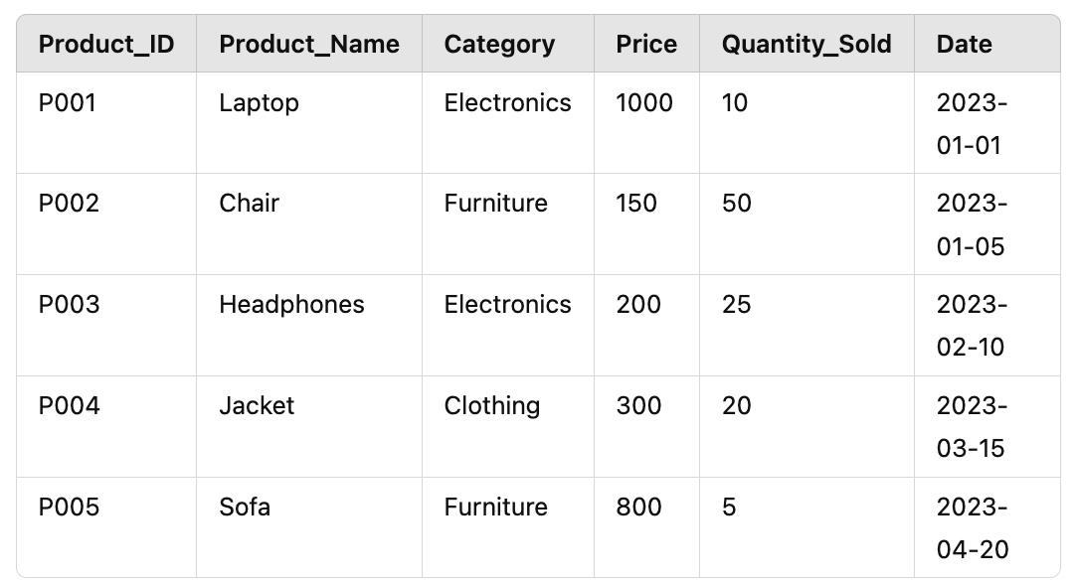
- Discuss how lists differ from other data structures like tuples and sets. Given a list- numbers = [2, 4, 6, 8, 10]. How to create a list and access its elements. How to modify, add, and remove elements from a list with examples, and sort the list in descending order.
(ii) Explain the concept of a NumPy Array and its applications in data analysis. Include the following in your answer:
a. What is a NumPy Series? How is it different from a Python list?
b. How do you create a NumPy Series? Provide an example with code.
c. Explain how mathematical operations can be performed on a NumPy Series.
d. Discuss the advantages of using NumPy Series for handling large datasets.
- Provide two practical examples of tasks where NumPy Series would be beneficial in data processing and analysis. Write a Python program to perform the following tasks using Pandas:
- Load an Excel file named employee_data.xlsx into a Pandas DataFrame. The Excel file contains the following columns: EmployeeID, Name, Department, Salary, JoinDate, and Experience.
- Display the last 10 rows of the DataFrame.
- Identify and handle missing values:
  - If there are missing values in the Salary column, fill them with the median of the Salary column.
  - For missing values in the Experience column, fill them with the value 0.
- Remove duplicate rows based on the EmployeeID column.
- Convert the JoinDate column to a datetime format.
- Filter the DataFrame to include only employees from the "HR" and "IT" departments, with a salary greater than 50,000.
- Save the cleaned and filtered DataFrame to a new Excel file named filtered_employee_data.xlsx.
- You are given a dataset called "student_scores.csv" that contains the following columns:

Name | Math_Score | Science_Score | English_Score
Alice | 78 | 85 | 92
Bob | 85 | 82 | 88
Charlie | 92 | 91 | 85
David | 88 | 79 | 78
Eva | 79 | 95 | 91
Frank | 76 | 84 | 77

a. Create a NumPy array using the above data for the first 5 students' Math scores.
b. Perform the following operations on the NumPy array:
i) Find the mean of the Math scores.
ii) Find the maximum and minimum Math scores.
- Create an Employee dataset for an organization. The data needs to be analysed. Load the given dataset into a Pandas DataFrame. Perform group by operations and calculate summary statistics.
Define data and what are the types of data. Display all the rows in the dataset. Explain how the DataFrame object can give more information about the data set. Also explain the various approaches in sorting and filtering methods to be performed on a Panda dataframe. Apply those various techniques in the given below dataset and derive the values.
Also mention how to get the statistical analysis of the given data.
StrengthFactor | PriceReg | ReleaseYear | ItemCount
682743 | 44.99 | 2015 | 8
1016014 | 24.81 | 2005 | 39
340464 | 46 | 2013 | 34
334011 | 100 | 2006 | 20
1287938 | 121.95 | 2010 | 28
1783153 | 132 | 2011 | 33
2314801 | 95.95 | 2010 | 33
721111 | 207.8 | 2011 | 57
436667 | 119.81 | 2008 | 36
6652211 | 49.95 | 2004 | 19

- Data are provided with the following arrays representing the scores of students in three subjects: Math, Science, and English.
math_scores = np.array([85, 78, 92, 88, 76, 79])
science_scores = np.array([82, 85, 91, 79, 84, 95])
english_scores = np.array([88, 92, 85, 78, 77, 91])
Write a Python program to perform the following tasks using NumPy:
i) Create a 2D NumPy array combining the Math, Science, and English scores of all students.
ii) Find the mean score for each subject (Math, Science, English) using the 2D array.
iii) Calculate the total score of each student by summing their scores across the three subjects.
iv) Find the highest total score among all students and the name of the student with the highest total score. You can assume the students' names are:['Alice', 'Bob', 'Charlie', 'David', 'Eva', 'Frank'].
- Consider the given employee salary dataset.
ID | Experience_Years | Age | Gender | Salary
1 | 5 | 28 | Female | 250000
2 | 1 | 21 | Male | 50000
3 | 3 | 23 | Female | 170000
4 | 2 | 22 | Male | 25000
5 | 1 | 17 | Male | 10000
6 | 25 | 62 | Male | 5001000
7 | 19 | 54 | Female | 800000
8 | 2 | 21 | Female | 9000
9 | 10 | 36 | Female | 61500
10 | 15 | 54 | Female | 650000
11 | 4 | 26 | Female | 250000

- Create a NumPy array and perform basic operations including python basics and control structures. Perform descriptive statistics analysis and include the correlation, co-variance as well. Plot the analysis using matplotlib and seaborn. Differentiate the uniqueness of each of these libraries.
- Load a dataset into a Pandas DataFrame and clean the data (handle missing values, drop unnecessary columns) and Perform group by operations and calculate summary Statistics, display the first 10 rows, and perform basic data manipulation (sorting, filtering).
Date | Store | Product | Sales | Quantity
2023-01-01 | Store A | Widget A | 200 | 10
2023-01-02 | Store A | Widget B | 150 | 5
2023-01-03 | Store B | Widget A | 300 | 15
2023-01-04 | Store B | Widget C |  | 8
2023-01-05 | Store A |  | 250 | 20
2023-01-06 | Store C | Widget A | 400 | 20
2023-01-07 | Store C | Widget B | 100 | 2
2023-01-08 | Store A | Widget C | 150 | 6
2023-01-09 | Store B | Widget B |  | 5
2023-01-10 | Store C | Widget C | 350 | 10

- Demonstrate how to create different types of plots (line plot, bar plot, scatter plot) using Matplotlib. Provide code examples. Explain how to add titles, labels (x and y axis), and customize colors in these plots. Include examples of customization in your code.
- Show how to create advanced visualizations such as a box plot and heatmap using Seaborn. Provide examples with code. Explain how to customize these Seaborn plots by adding titles, labels, changing color palettes, and enhancing the visual appeal
- Write a Python program that demonstrates key concepts from the following topics: Python data structures, functions, and data analysis using libraries like NumPy, Pandas, and Matplotlib. The program should:
- Define a function called analyze_sales_data() that accepts a list of sales figures (integers) and performs the following tasks:
  - Calculate and return the total, maximum, minimum, and average sales from the list.
- Create a NumPy array from the given sales figures and perform basic statistical operations on the array (sum, mean, median).
- Convert the NumPy array into a Pandas DataFrame and create an additional column for "Region" which is randomly chosen from ['North', 'South', 'East', 'West'].
- Plot a bar chart of total sales per region using Matplotlib.
Demonstrate basic error handling by checking if the input list is empty and raising an appropriate exception.
- Create a dataframe using Python for the given table to analyse the workout sessions in a Fitness center. Perform data preprocessing on the given data. Explain the various ways to handle the empty data, wrong data, wrong format and duplicates.
Explain in detail about exploratory data analysis (EDA) and descriptive statistics.
Duration | Pulse | Maxpulse | Calories
60 | 110 | 130 | 409.1
60 | 117 | 145 | 479
60 | 103 | 135 | 340
45 | 109 | 175 | 282.4
60 | 98 | 124 | 269
60 |  | 147 | 329.3
60 | 100 | 120
240 | 106 | 128 | 345.3
60 | 104 | 132 | 379.3
Apply these various commands on the given dataset and plot the analysis results.

Unit 3
Problems with tree solving with the following algorithms
  - breadth first search,
  - depth first search,
  - depth limited search,
  - comparing uniform search strategies.
  - Greedy best -first search,
  - A* search
  - AO* search,

Sample problems are given here.

Part – A ( 2 x 20 = 40 Marks) Instructions: Answer all questions
Q. No | Question | Marks | BL | CO | PO | PI Code | Marks Scored
 | - Explain the working principle of Breadth First Search (BFS) and depth first search (DFS) algorithm. Provide a step-by-step illustration with the help of a sample graph.(7M)  - You are developing an AI system to find the shortest path for a delivery robot navigating through a city grid given below with varying terrain costs. Describe how you would implement the A* Search algorithm for this scenario, considering factors such as heuristic functions, node expansion, and path cost evaluation. .(6M)  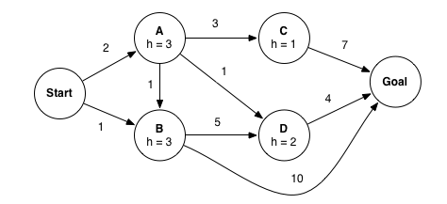  - Given the graph below, demonstrate how the A* algorithm searches for the shortest path from node A to node J. In your explanation, highlight how A* combines the advantages of Breadth First Search (BFS) and Best First Search (BFS) through its use of heuristics. Also, discuss the importance of the chosen heuristic being both admissible and consistent. (7M)  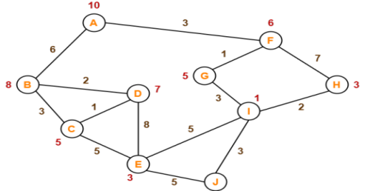 | 20 | 3 | 3 | 2,3 | 3.6.3

Unit 4
Problems solving with the following algorithms

- Local search for constraint satisfaction problems.
- Minimax search procedure-
- alpha-beta pruning,

sample questions:

- Solve the following crypt arithmetic problem and write the step-by-step process. (7M)
Find the value of W + I + N + T + E + R
if: W I N T E R + S U M M E R = A U T U M N

- Consider a scenario where you are implementing a chess-playing AI using the minimax algorithm with alpha-beta pruning. The AI evaluates potential moves in a particular game state, and you have implemented the alpha-beta pruning algorithm to improve the efficiency of the search. (8M)
In a specific branch of the game tree, the AI is currently evaluating a node with a depth of 3. The alpha value at the parent node is 2, and the beta value is 5. During the evaluation of the child nodes, the AI finds that the alpha value at one of the child nodes is 4.
- Describe how alpha-beta pruning would affect the further exploration of the sibling nodes.
- Explain whether the AI would continue to evaluate the sibling nodes in this scenario or if any nodes would be pruned. Justify your answer.

(c ) Describe the main idea behind Alpha-Beta Pruning and how it reduces the number of nodes evaluated in a search tree. Find the pruning part of the tree given below((7M)
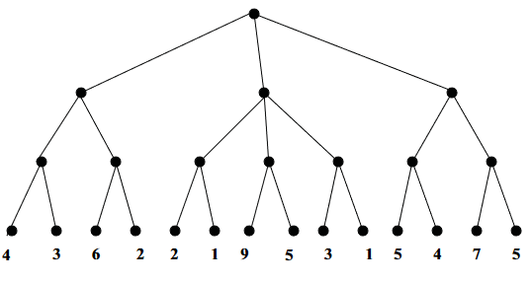

Unit 5

Describe Dempster Shafer theory with an Example
a. Explain Knowledge based Agents and its Architecture
b. Brief about Data Mining Techniques in Uncertain knowledge reasoning
Explain Fuzzy logic with suitable examples
How inference rules are used to represent knowledge
Certain knowledge needs to be represented over time. Explain those techniques

a) State Dempster Shafer theory with an Example.
b)Justify how this theory can be used in uncertain knowledge reasoning process

a. Comment on knowledge based agents and its architecture.
b. Write in brief about Bayes theorem in Uncertain knowledge reasoning.

Define Fuzzy logic, Fuzzy sets and basic operations in Fuzzy logic
Use the following facts and prove the goal: You are not swimming

(1) If you go swimming you will get wet.
(2) If it is raining and you are outside then you will get wet.
(3) If it is warm and there is no rain then it is a pleasant day.
(4) You are not wet.
(5) You are outside.
(6) It is a warm day.
Show that the hypotheses:

It is not sunny this afternoon and it is colder than yesterday.
We will go swimming only if it is sunny.
If we do not go swimming, then we will take a canoe trip.
If we take a canoe trip, then we will be home by sunset.

Lead to the conclusion:
We will be home by the sunset.

Show that the premises:
A student in Section A of the course has not read the book.
Everyone in Section A of the course passed the first exam.
imply the conclusion
Someone who passed the first exam has not read the book.

A(x): “x is in Section A of the course”
B(x): “x read the book”
P(x): “x passed the first exam.”
Hypotheses: ∃x(A(x) ∧ ¬B(x)) and ∀x(A(x) → P(x)).
Conclusion: ∃x(P(x) ∧ ¬B(x)).

For each of the following arguments, explain which rules of inference are used for each step. The universe is the set of people.

- "Every student in this class owns a personal computer. Everyone who owns a personal computer can use the Internet. Therefore, John, a student in this class, can use the Internet."
- "Everyone in this class owns a personal computer. Someone in this class has never used the Internet. Therefore, someone who owns a personal computer has never used the Internet."

For each of the following arguments, explain which rules of inference are used for each step. The universe is the set of people.

- "John, a student in this class, is 16 years old. Everyone who is 16 years old can get a driver's liscence. Therefore, someone in this class can get a driver's liscence."
- "Someboday in this class enjoys hiking. Every person who enjoys hiking also likes biking. Therefore, there is a person in this class who likes biking."

What is Semantic Network?
· Tom is an instance of dog.
· Tom caught a cat
· Tom is owned by roshan.
· Tom is brown in colour.
· Dogs like bones.
· The dog sat on the mat.
· A dog is a mammal.
· A cat is an instance animal
· All mammals are animals.
· Mammals have fur.

Use the above facts and using Semantic network conclude Tom is a Mammal
Calculate the probability that the Alarm rings (A) given that:

John Calls (J)
Mary Calls (M)
Earthquake doesn't happen (~E)
Burglary doesn't happen (~B)

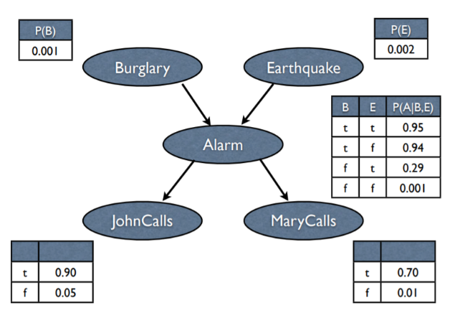
Give the syntax, semantic and inferencing mechanisms in Frames with example
Define Fuzzy logic, Fuzzy sets and basic operations in Fuzzy logic
Differentiate Forward and Backward Reasoning
Use the following facts and prove the goal: You are not swimming

(1) If you go swimming you will get wet.
(2) If it is raining and you are outside then you will get wet.
(3) If it is warm and there is no rain then it is a pleasant day.
(4) You are not wet.
(5) You are outside.
(6) It is a warm day.
Use the following facts and prove the goal : You are not doing strawberry picking

(1) If it is sunny and warm day you will enjoy.
(2) If it is warm and pleasant day you will do strawberry picking
(3) If it is raining then no strawberry picking.
(4) If it is raining you will get wet.
(5) It is warm day
(6) It is raining
(7) It is sunny

1 | Show that the following premises:  - A student in Section A of the course has not read the book.  - Everyone in Section A of the course passed the first exam.  Imply the following conclusion :  - Someone who passed the first exam has not read the book.
2 | Calculate the probability that the Alarm rings (A) given that:  - John Calls (J)  - Mary Calls (M)  - Earthquake doesn't happen (~E)  - Burglary doesn't happen (~B)

Describe Dempster Shafer theory with an Example
a. Explain Knowledge based Agents and its Architecture [5
b. Brief about Data Mining Techniques in Uncertain knowledge reasoning
Explain Fuzzy logic with suitable examples
How inference rules are used to represent knowledge
Certain knowledge needs to be represented over time. Explain those techniques

For each of the following arguments, explain which rules of inference are used for each step. The universe is the set of people.

- "Every student in this class owns a personal computer. Everyone who owns a personal computer can use the Internet. Therefore, John, a student in this class, can use the Internet."
- "Everyone in this class owns a personal computer. Someone in this class has never used the Internet. Therefore, someone who owns a personal computer has never used the Internet."

Consider the following premises:
A student in Section A of the course has not read the book.
Everyone in Section A of the course passed the first exam.
And infer the following conclusion:
Someone who passed the first exam has not read the book.

- Explain Knowledge based Agents and its Architecture [5 Marks]
- Brief about Data Mining Techniques in Uncertain knowledge reasoning[5 Marks]

Use the following facts and prove the goal: You are not swimming

(1) If you go swimming you will get wet.
(2) If it is raining and you are outside then you will get wet.
(3) If it is warm and there is no rain then it is a pleasant day.
(4) You are not wet.
(5) You are outside.
(6) It is a warm day

